Shadows over Blackstone Keep
Players: 4
Level: 3
Length: 3–4 hours

Narrative Setup
The adventure begins immediately. The players arrive at the edge of Oakhollow. Smoke chokes the sky, throwing the looming sunset into crimson shadows. Houses crackle in flames as villagers flee down the dirt roads.
Instead of slaughtering everyone blindly, this raiding party is organized: they are targeting specific storehouses to steal supplies, maps of the Blackstone Valley, and an ancient dwarven key. Crucially, they have also captured Elder Hadrick, the village's old blacksmith and the only living soul who knows how to decipher the ancient dwarven milestones scattered through the Blackwood Forest.

Objectives
- Save the remaining villagers and douse critical fires.
- Drive off or eliminate the tactical raiders.
- Rescue Elder Hadrick or recover the map dropped in the chaos.

Combat 1: The Oakhollow Raiders
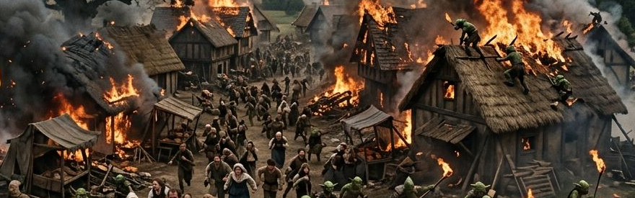

Enemies: 3 Goblin Skirmishers, 1 Goblin Archer, 1 Worg.
- Battlefield Environment: The village square. Burning wooden beams create lines of sight blockage. Choking smoke acts as light cover (+2 AC/Dex saves) if standing inside marked zones. One thatch-roof tavern stands mostly intact but burning at the base.
- Tactics & Synergy: * Dynamic Hit-and-Run: The 3 Goblin Skirmishers use the smoke screens to their advantage. They dart out from burning storefronts, slash with their scimitars (+4 to hit, 1d6+2), and immediately use Nimble Escape as a bonus action to Disengage or Hide behind debris.
  - Roof Sniper: The Goblin Archer starts on the thatch roof of the tavern. It uses its Aimed Shot trait to pressure low-health backline characters, dealing an extra 1d6 damage if it successfully recharges (5–6). If a player scales the building to engage it, the archer uses its movement to jump across to an adjacent low wagon or fence, retreating rather than staying in melee.
  - Worg Chaos: The Worg surges directly into the frontline martial characters. It utilizes its Bite (+5 to hit, 2d6+3). On a hit, the player must pass a DC 13 Strength saving throw or be knocked prone by the Knock Down trait. The moment a hero falls flat on their back, the Goblin Skirmishers swarm out of the smoke to strike with advantage.
Aftermath & Clues
Once the raiders fall or scatter, the heroes find a crude map dropped by a fleeing goblin. The map charts a path deep into the Blackwood Forest directly toward a location marked "The Broken Bridge." A wounded, soot-stained ranger stumbles forward, coughing out: "They dragged Elder Hadrick away... Kragath has already entered the valley. If he reaches the Heartforge with that key... we're finished."
Scene 2 – Through Blackwood Forest
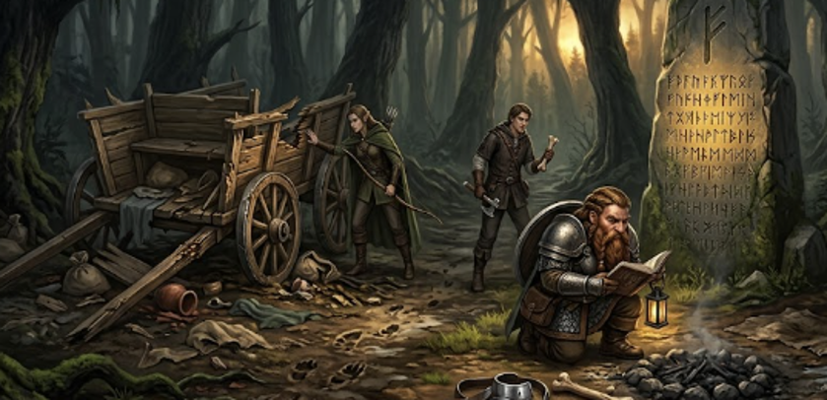
Exploration & Environmental Storytelling
The players push into the dense, dark foliage of the Blackwood Forest, tracking the fresh bootprints and claw marks of the warband. Instead of simple Survival checks, the forest serves to build narrative tension and foreshadow upcoming threats:
- The Torn Wagon: The heroes stumble upon a shattered merchant cart. The wood isn't splintered by axes, but splintered by massive, crushing jaws—introducing the terrifying destructive force of Worgs before the players encounter another one.
- The Fragmented Campfire: The party finds the remains of a recent vanguard campsite. A brief investigation reveals a strict, harsh hierarchy: the goblin skirmishers were forced to sleep in the mud and dirt away from the fire, while the larger hobgoblin soldiers took the only dry ground, leaving behind discarded marrow bones and polished armor straps.
- Dwarven Milestones: Deep in the woods stand ancient, mossy stone monoliths. If a player reads Dwarvish (or checks the recovered village records), they can decipher ancient runes carved into the rock: "Beware the Heartforge's light; it warms the just, but burns the greedy." This foreshadows the room mechanics in the final encounter.
- Hazard: Giant spider webs block a narrow ravine shortcut. The players can choose to clear them quietly (Athletics/Sleight of Hand checks) or take a longer route that ticks down their remaining time before sunset.

Scene 3 – The Broken Bridge
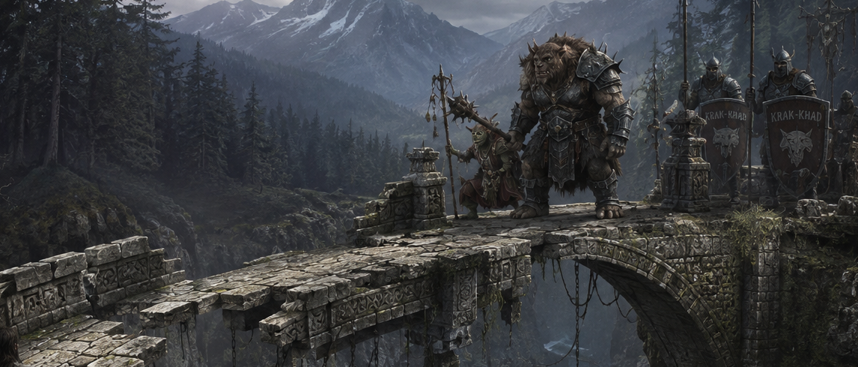
Narrative Setup
The forest path ends abruptly at the edge of a massive, rocky gorge. A grand stone dwarven bridge once spanned the gap, but half of it has collapsed into a churning river hundreds of feet below. Across the remaining side of the bridge waits a heavily armed hobgoblin blockade, sent by Kragath to secure the bottleneck and prevent any pursuit.
Before combat breaks out, players can overhear a tense argument across the canyon: a Goblin Hexer is shrilly berating a massive Bugbear Brute, trying to explain the tactical importance of holding the defensive line, while the bugbear growls in frustration, eager to move forward and smash things.
The Encounter: The Bottleneck Choke
Enemies: 2 Hobgoblin Soldiers, 1 Bugbear Brute, 1 Goblin Hexer.
- Battlefield Environment: A narrow, stable stone path leading to a 15-foot gap over the gorge. Planks of wood, ropes, and crumbling stone pillars offer methods to cross or swing over.
[Party Side] ===[ 15-ft Gap ]=== [Hobgoblin Soldiers] === [Hexer / Bugbear]
- Tactics & Synergy:
  - The Phalanx Wall: The 2 Hobgoblin Soldiers advance to the narrowest choke point on the far side of the gap, locking their shields together. Because they are adjacent, their Shield Wall trait triggers, boosting their Armor Class to a formidable 18 and increasing their Longsword damage to 1d8+4. They form an impenetrable wall, refusing to budge.
  - The Bugbear Ambush: The Bugbear Brute uses the rocky clefts and crumbling stonework near the bridge edge for cover. Instead of rushing blindly across the gap, it waits out of sight. The moment a player uses a rope, leaps across, or climbs the masonry to bypass the shield wall, the bugbear leaps from hiding to activate its Ambusher trait, dealing a devastating extra 2d6 damage on its first morningstar hit.
  - The Hexer’s Ritual: The Goblin Hexer stands safely behind the shield wall. On Round 1, it casts Smoke Cloud, creating a 10-foot heavily obscured area right where the players are trying to land their jumps or climb up. On Round 2, it targets the party's heaviest hitter with its Curse ability, forcing disadvantage on their next attack. On Round 3, it utilizes Battle Chant, granting the Bugbear Brute an immediate out-of-turn movement or attack to crush an exposed player.
- Alternative Approaches: Players can exploit the faction tension. A clever illusion or a successfully shouted deception check mimicking Kragath's voice can trick the impatient Bugbear Brute into breaking formation and charging across the unstable beams, ruining the Hobgoblins' defensive synergy.
Aftermath & Rewards
Once defeated, the heroes find a collection of healing potions, an ancient dwarven map detailing the interior layout of Blackstone Keep, and a heavy iron key meant to open the keep's outermost perimeter gate.
Scene 4 – Blackstone Keep
Rather than an exhausting, sprawling dungeon crawl, the keep is a compact, high-stakes gauntlet consisting of three functional chambers.
Room A: The Collapsed Hall
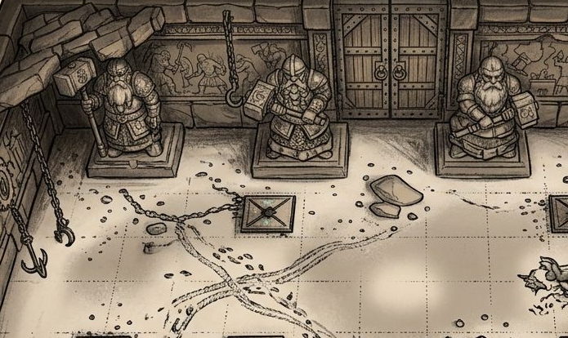
- The Setup: The heavy iron doors unlock to reveal a grand, dusty hall lined with monumental dwarven statues holding stone hammers. The floor is covered in a thick, unnatural layer of white dust left behind by Kragath’s vanguard.
- The Tension Builder: As the players move through, the shadows cast by their torches cause the statues to appear to lean or shift. In reality, the statues do absolutely nothing—they are completely mundane stone.
- The Hidden Danger: Near the center of the room, the players discover the crushed corpse of a Goblin Skirmisher pinned under a fallen piece of ceiling masonry. Tucked into its leather armor is a scrap of parchment with a frantic goblin scrawl: "The statues watch, but the floor is what bites." This alerts the players to look closely at the floor, transforming a standard stroll into a tense investigation to spot hidden pressure plates that trigger swinging iron chains from the ceiling.

Room B: The Forge Locks
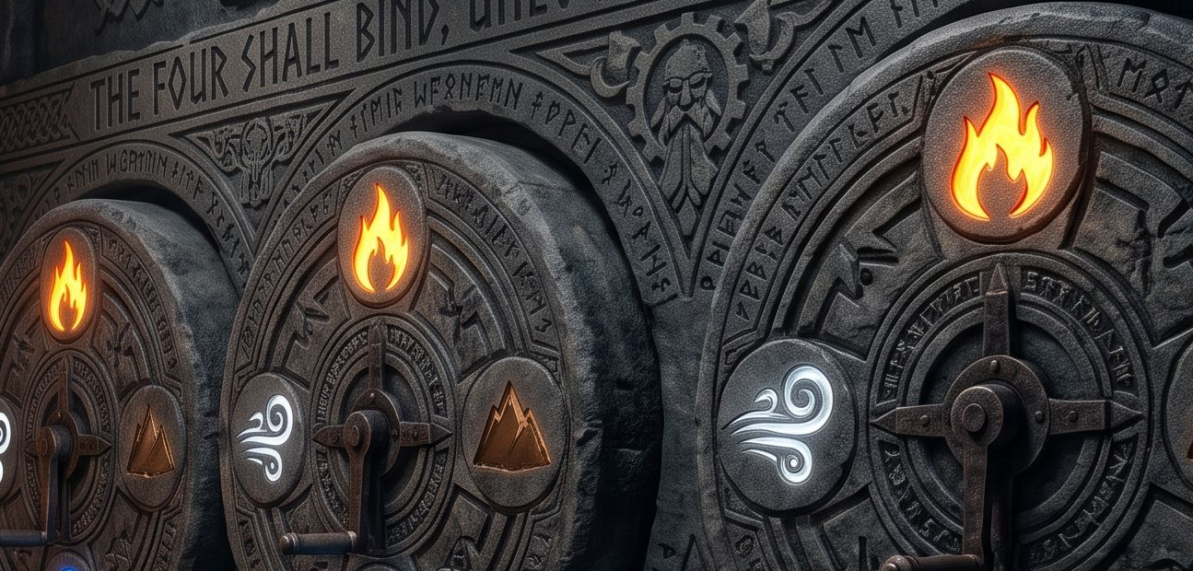
- The Setup: The exit to this room is a pair of towering, solid iron doors etched with massive gears. Four ancient dwarven stone wheels are built into the wall next to them, each carved with a glowing, mystical rune. Clues regarding the proper alignment of the runes are etched into the surrounding masonry.

- The Interrupted Puzzle: Solving the puzzle requires a character to spend their Action and succeed on an Athletics check to physically rotate the heavy iron gears into place.
- The Ambush: Just as the players deduce the combination and begin turning the first wheel, a concealed stone panel slides open. Kragath left a rear-guard ambush: 2 Goblin Skirmishers slip out from the dark alcoves to strike at the puzzle solvers.
- The Choice: This creates a split-focus dynamic encounter. The party's frontline fighters must hold off the agile, hit-and-run skirmishers, while the rogue or spellcaster must focus on completing the physical puzzle rotations to open the enormous vault doors before the room fills with reinforcements.
Room C: The Heartforge (The Final Battle)
- The Setup: The vault doors grind open to reveal a massive, breathtaking circular chamber. Great stone channels hum with glowing molten lava, surrounding a central platform connected by narrow, broken iron bridges and swinging chains. Deep beneath the floor grates, the core of the ancient Heartforge pulses with an angry, blinding orange light. Kragath Iron Fang stands at the central control altar, holding the primary dwarven key as the machinery awakens.
Final Battle Roster
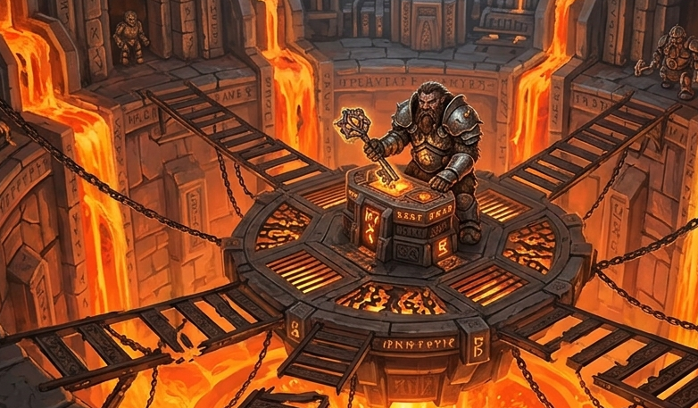
- Kragath Iron Fang (Warlord Boss, 85 HP)
- 2 Hobgoblin Soldiers (Front-line Vanguard)
- 1 Goblin Archer (Perched on a high iron crane platform)
- (Optional: 1 Goblin Hexer if the party enters the room fully healed and at high resources)
[Goblin Archer on Crane]
|
[Lava Channel] ---- [Hobgoblin Soldier] ---- [Lava Channel]
|
[KRAGATH AT THE ALTAR]
|
[Lava Channel] ---- [Hobgoblin Soldier] ---- [Lava Channel]
|
[Broken Iron Bridge]
|
[Party Enters]
Warlord Tactics & Mechanical Synergy
- The Commander's Aura: Kragath is a master military tactician. His passive Commander aura grants all allies within 30 feet a +1 bonus to hit, making the Archer's longbow and the Soldiers' longswords significantly deadlier.
- Guardian Phalanx: The 2 Hobgoblin Soldiers lock shields directly in front of Kragath, using their high AC 18 and Shield Wall to absorb melee attacks and block the party from rushing the warlord.
- Phase 2 Transition (Second Wind): Track Kragath's health carefully. The exact moment he drops below 42 HP (half of his 85 HP maximum), he triggers his Second Wind trait as a reaction. The Heartforge pulses violently, channeling raw magical energy into his armor and instantly restoring 20 HP.
- Kragath's Relic (The Heartforge Ember): Kragath pulls a glowing, unstable magical crystal from the forge altar. Once during the fight, he can slam it into the iron floor grates to unleash a 15-foot cone of fire (DC 13 Dexterity save or take 3d6 fire damage). This forced area-of-effect attack forces the players to scatter across the dangerous, narrow bridges rather than grouping up to surround him.
Dynamic Battlefield Events
At the start of each round (Initiative Count 20), the awakening forge alters the arena, forcing constant movement:
- Round 1 (The Awakening): The room violently shakes as the gears turn. The entire chamber is treated as difficult terrain due to tremors, except for characters standing on the solid iron grates or main stone pillars.
- Round 2 (Steam Eruption): A line of heavy iron pipes bursts. Hot steam erupts, completely blocking sight and creating a line of total concealment across a 10-foot wide path.
- Round 3 (Bridge Collapse / Battle Cry): A section of the eastern iron walkway shears off and drops into the lava. Immediately following this environmental distraction, Kragath lets out his Battle Cry, allowing all surviving goblins and hobgoblins to instantly take an out-of-turn movement action to pin down the disoriented heroes.
Ending & Escape Sequence
When Kragath falls, his body slumps over the altar, accidentally fracturing the primary key inside the control mechanism. The ancient Heartforge becomes highly volatile, and the chamber begins to self-destruct as lava channels overflow.
- The Escape: The players have exactly 5 rounds to navigate the crumbling keep. The environment requires teamwork—strong characters must make Athletics checks to lift falling iron portcullises, while agile characters use Acrobatics to clear widening lava fissures, pulling their allies across to safety.
- The Return: The heroes burst through the outer gates of Blackstone Keep just as the stone towers collapse inward in a spectacular cloud of dust and harmless magical sparks.
- The Reward: The sky clears, and the sun sets peacefully over a saved valley. The grateful villagers of Oakhollow cheer their return, and the rescued Elder Hadrick presents them with their due rewards. As a lingering sign of their victory, the benevolent dwarven spirits of the forge bless the heroes: each player receives a small, customized magical gift drawn from the dying embers of the forge—such as a +1 weapon, a protective charm, or a glowing heirloom shield—marking them forever as the Saviors of Blackstone Keep.

Puzzle Design: The Forging Order
The Visual Setup
Built into the wall next to the iron vault doors are four stone wheels arranged horizontally from left to right. Each wheel features the same four foundational symbols:
- 🔥 Flame (Heat)
- 🪨 Iron (Metal)
- 💨 Bellows (Air)
- 💧 Quench (Water)
The Clues (Player Handouts)
Clue 1: The Inscription (Carved in the Stone Lintel)
"To wake the Heartforge, mimic the master smith's work. First, blast the coals with wind. Second, heat the coals with fire. Third, shape the heavy metal. Fourth, cool it in the deep waters."
Clue 2: The Vanguard's Scratch-Mark
Near the wall, a dead goblin has crudely scratched a drawing into the stone floor:
- It shows a crude arrow pointing from the left wheel to the right wheel (1 ➔ 2 ➔ 3 ➔ 4), indicating that the puzzle reads from left to right.
The Solution
The players just have to arrange the elements in the exact step-by-step order described in the lintel riddle:
- "First, blast the coals with wind" ➔ Wheel 1 = Bellows 💨
- "Second, heat the coals with fire" ➔ Wheel 2 = Flame 🔥
- "Third, shape the heavy metal" ➔ Wheel 3 = Iron 🪨
- "Fourth, cool it in the deep waters" ➔ Wheel 4 = Quench 💧
Wheel 1 (Far Left) | Wheel 2 | Wheel 3 | Wheel 4 (Far Right)
💨 Bellows | 🔥 Flame | 🪨 Iron | 💧 Quench
Running the Encounter Mechanics
- Interaction: Turning a rusted stone wheel requires a DC 10 Strength (Athletics) check as an Action.
- The Ambush Trigger: The moment the players successfully align the first two wheels (Bellows and Flame), a grinding mechanism echoes down the hall. This sound triggers the hidden side panel to slide open, and 2 Goblin Skirmishers drop out to ambush them while they try to turn the remaining two wheels.
- Incorrect Guess: If a player forces a wheel into an incorrect position, a small vent lets out a hiss of boiling steam, dealing 1 fire damage (no roll needed, just a minor penalty to add tension) to the character turning it.

